Napkin Drawings

# Dashboard Napkin Drawings

## First Draft

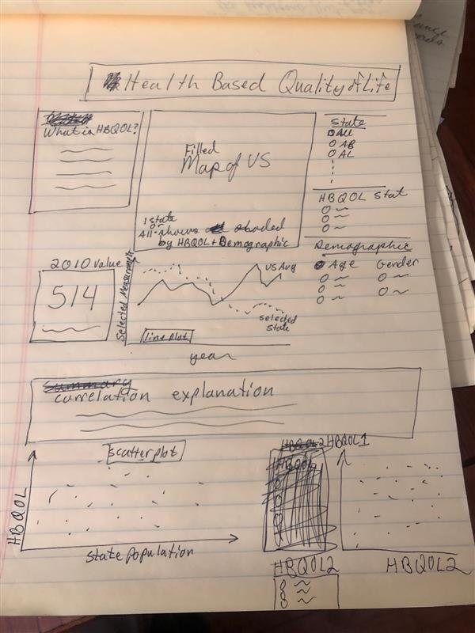

M05 Mastery Napkin drawing. Audience general public interested in how states compare to each other. I am already going to swap out the bottom section with a Top 10 column chart for the three hbqols I will use. I’ll save the correlation charts for the report.

## Feedback

[12:26 AM] Annie Kittendorf

Hi, Darrell! It looks like you’re focusing mainly on how location, age, and gender impact health-based quality of life with an emphasis on location. Is that your intention? I like that you plan to give your audience context about HBQL, but be careful not to be too wordy here. Which HBQL stat do you plan on excluding? I like your plan to compare state values to the national value although I’m confused about what the 514 card represents. It also looks like you’re focusing only on the year 2010. If this is the case, I would include that in your title so it’s very clear from the beginning. I agree with your plan to save the correlations for the report and think the top ten is a good substitution. Top 10 what though, states? Overall though I think you’re on a good track!

[12:40 AM] Dalton Bode

I like the definition text box explaining what HBQOL is, I definitely need to include something like that in my dashboard! The line graph is also an interesting twist for comparing each HBQOL metric throughout the years between the state and national levels. Similarly to Justin's, I think adding some trendlines to the scatter plots would be visually effective in relaying the correlation between the two variables you're investigating (for the report). For the Top 10 charts, I'd recommend horizontal bar charts for the visualizations.

## Results of Feedback

* Be more explicit in the title that the dashboard will show a select few quality-of-life measurements for different demographics based upon the location (state).
* Move the 2010 card to the end of the line graph and make it clearer that it shows the last data point.
* Replace the correlation data at the bottom with graphs showing the top 5 and bottom 5 states for each selected measurement.
* When I do the correlation scattlerplots for the report, I will add a trendline. This does not appear to be an option in PowerBI so it will require using an Excel graph.
* Use horizontal bar charts for categorical data (linked ranked states) versus vertical bar charts which are better suited to ordinal or sequential data.

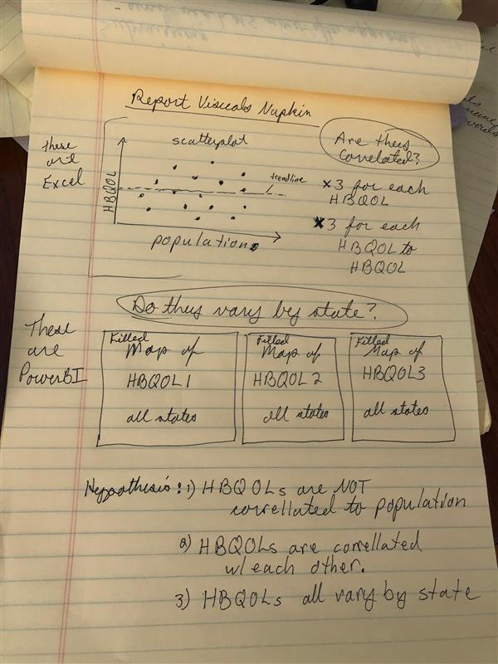

## Feedback:

[Yesterday 3:37 PM] Gregory Wagner

I think you've done a great job of creating visualizations that demonstrate the relationships you are testing. I am wondering, though, if maybe there will be too many scatterplots in the report? Maybe just having the correlation matrix for some of these relationships is adequate in testing your hypothesis. I'm definitely splitting hairs with this suggestion because I think you've done a good job overall and I personally don't see much need of significant changes.

(1 liked)

[Yesterday 6:22 PM] Grace Seiler

Hi Darrell, I think I agree with Greg that there might just be a lot going on with that many scatter plots. I would suggest doing a correlation matrix and potentially showing the "interesting" correlations as scatter plots and not just all. Of course, this can sometimes be tricky to not make it look like the data is leaning one way (when in actuality it is not)! So be careful.

(1 liked)

## Results of Feedback

* I took the concern about the large number of scatterplots into account but in a different way than suggested. Instead of reducing the number of scatterplots, I decided to organize them as a matrix of small plots that reduce much of the visual complexity of the points into a blob. I did a test run and it seems to work well and still makes it clear which combinations of parameters have low residual error and which are very scattered.
* I will also add some additional graphs to get gain a better understanding of the data. I’ll do some basic

## Updated Napkin drawing for report